DOM Tree

**What is a DOM tree?**

A DOM tree is a tree structure whose nodes represent an HTML or XML document's contents. Each HTML or XML document has a DOM tree representation. For example, consider the following document:

HTML

<html lang="en">

<head>

<title>My Document</title>

</head>

<body>

<h1>Header</h1>

<p>Paragraph</p>

</body>

</html>

It has a DOM tree that looks like this:

The DOM as a tree-like representation of a document that has a root and node elements containing content

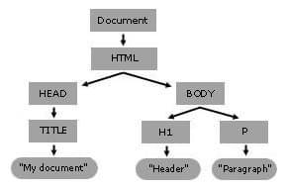

Navigate to DOM Tree

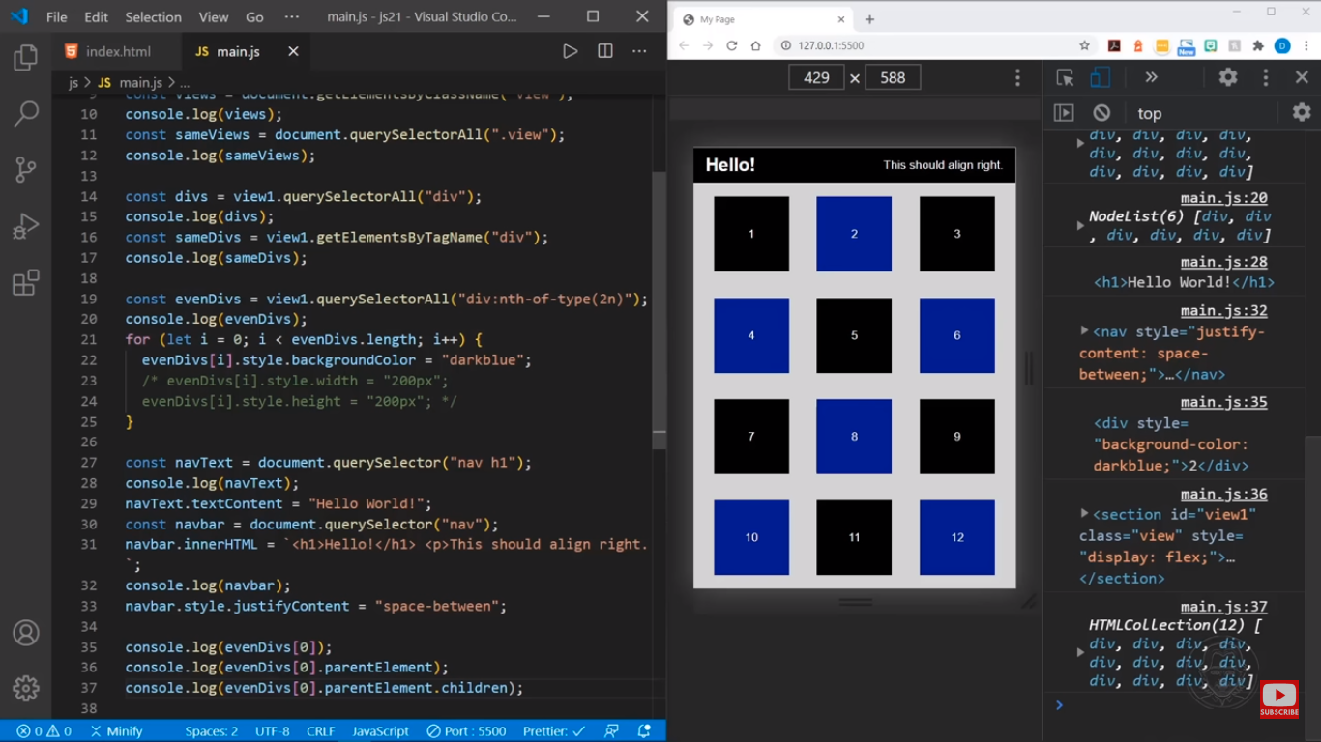

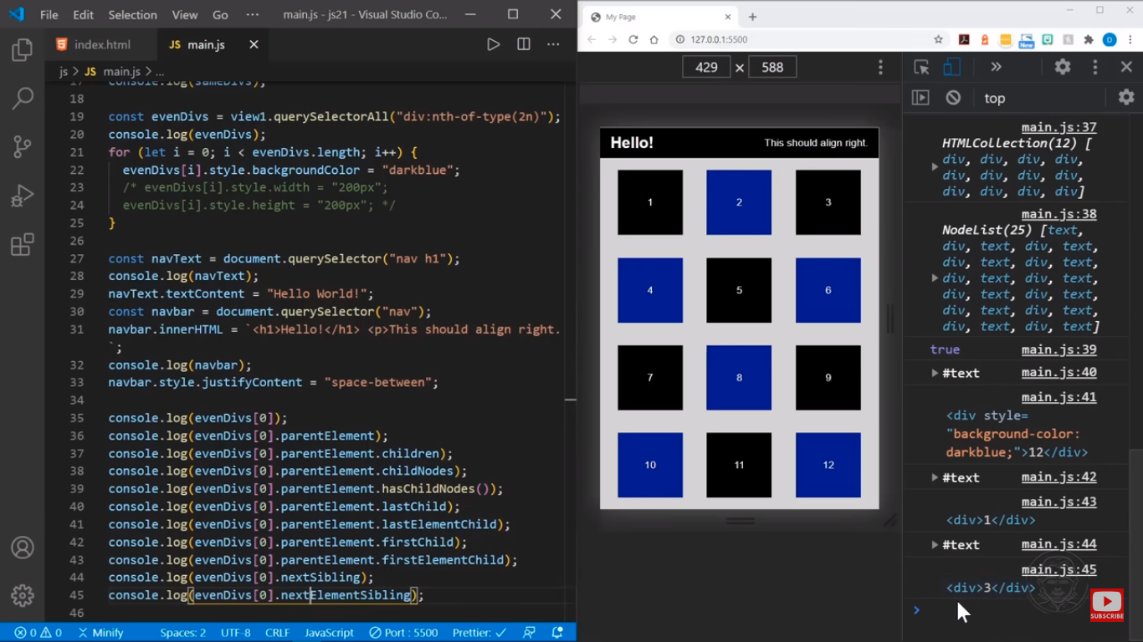

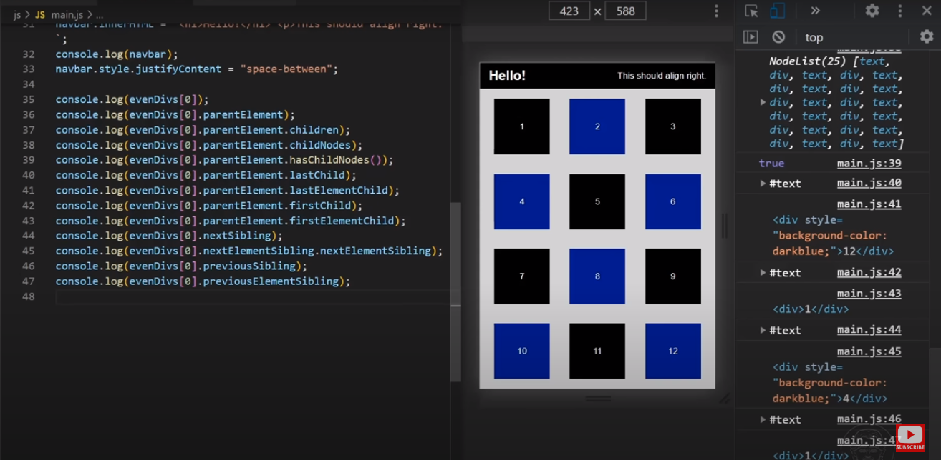

DOM Methods